**SSN COLLEGE OF ENGINEERING**

**DEPARTMENT OF COMPUTER SCIENCE AND ENGINEERING**

**UCS1712 – GRAPHICS AND MULTIMEDIA LAB**

**EX NO: 6a – 2D Transformations – Composite Transformation**

**Name: Nachammai Devi Pooja S**

**RollNo:185001096**

**Date:9/09/2020**

**Aim:**

To write a C++ menu-driven program using OPENGL to perform 2D composite transformations for polygons.

**Algorithm:**

Step 1: Obtain no. of edges of polygon from user

Step 2: Obtain coordinates of vertices

Step 3: Plot the original polygon and line

Step 4: Obtain transformation option from user

Step 5: option 1 – Rotation & Scaling:

* Get angle of rotation(theta), fixed point (x,y) and scaling factors as input

from user

* Translate the polygon by -x and -y
* Rotate polygon by theta
* Translate the rotated polygon back by x and y
* Scale the polygon by scaling factors and plot final polygon

multiply -1 to the Y coordinates of the original polygon and plot

Step 6: option 2-Reflection & Shearing:

-> Get reflection axis, shearing axis and shearing factor as input from user

-> Reflect the original polygon along the given reflection axis

-> Shearing the reflected polygon along the given shearing axis by the given

shearing factor and plot final polygon

**Code:**

#include <stdio.h>

#include <math.h>

#include <iostream>

#include <vector>

#include <gl/glut.h>

using namespace std;

int pntX1, pntY1, op = 0, edges, op1, op2;

int shearingX, shearingY;

vector<int> pntX, tempX;

vector<int> pntY, tempY;

int transX, transY;

double scaleX, scaleY;

double angle, angleRad;

char reflectionAxis;

double round(double d)

{

return floor(d + 0.5);

}

void drawPolygon()

{

glBegin(GL_POLYGON);

glColor3f(0.4, 0, 0.2);

for (int i = 0; i < edges; i++)

{

glVertex2i(pntX[i], pntY[i]);

}

glEnd();

}

void translate(int x, int y)

{

glBegin(GL_POLYGON);

glColor3f(6.08, 0.67, 1.0);

for (int i = 0; i < edges; i++)

{

pntX[i] += x;

pntY[i] += y;

//glVertex2i(pntX[i], pntY[i]);

}

glEnd();

}

void scale(double x, double y)

{

glBegin(GL_POLYGON);

glColor3f(6.08, 0.67, 1.0);

for (int i = 0; i < edges; i++)

{

pntX[i] = round(pntX[i] * x) + 300;

pntY[i] = round(pntY[i] * y);

glVertex2i(pntX[i], pntY[i]);

}

glEnd();

}

void rotate(double theta)

{

glBegin(GL_POLYGON);

glColor3f(6.08, 0.67, 1.0);

for (int i = 0; i < edges; i++)

{

int pntX1 = pntX[i];

int pntY1 = pntY[i];

pntX[i] = round((pntX1 * cos(theta)) - (pntY1 * sin(theta)));

pntY[i] = round((pntX1 * sin(theta)) + (pntY1 * cos(theta)));

//glVertex2i(pntX[i],pntY[i]);

}

glEnd();

}

void reflectX()

{

for (int i = 0; i < edges; i++)

{

pntY[i] = pntY[i] * -1;

}

}

void reflectY()

{

for (int i = 0; i < edges; i++)

{

pntX[i] = pntX[i] * -1;

}

}

void reflectOrigin()

{

for (int i = 0; i < edges; i++)

{

pntX[i] = pntX[i] * -1;

pntY[i] = pntY[i] * -1;

}

}

void reflectDiag()

{

for (int i = 0; i < edges; i++)

{

int temp = pntX[i];

pntX[i] = pntY[i];

pntY[i] = temp;

}

glEnd();

}

void shearX()

{

glBegin(GL_POLYGON);

glColor3f(0.3, 0.4, 0.7);

glVertex2i(pntX[0] + 150, pntY[0]);

glVertex2i(pntX[1] + shearingX + 150, pntY[1]);

glVertex2i(pntX[2] + shearingX + 150, pntY[2]);

glVertex2i(pntX[3] + 150, pntY[3]);

glEnd();

}

void shearY()

{

glBegin(GL_POLYGON);

glColor3f(0.3, 0.4, 0.7);

glVertex2i(pntX[0] + 150, pntY[0]);

glVertex2i(pntX[1] + 150, pntY[1]);

glVertex2i(pntX[2] + 150, pntY[2] + shearingY);

glVertex2i(pntX[3] + 150, pntY[3] + shearingY);

glEnd();

}

void myInit(void)

{

glClearColor(1.0, 1.0, 1.0, 0.0);

glColor3f(0.0f, 0.0f, 0.0f);

glPointSize(4.0);

glMatrixMode(GL_PROJECTION);

glLoadIdentity();

gluOrtho2D(-640.0, 640.0, -480.0, 480.0);

}

void myDisplay(void)

{

while (true) {

glClear(GL_COLOR_BUFFER_BIT);

glColor3f(0.0, 0.0, 0.0);

drawPolygon();

cout << "\nSelect the required Composite Transformation:\n";

cout << "1. Rotation & Scaling\n";

cout << "2. Reflection & Shearing\n";

cout << "3. Exit\n";

cout << "Enter your choice : ";

cin >> op;

if (op == 3) {

break;

}

if (op == 1)

{

cout << "Enter the angle for rotation: "; cin >> angle;

angleRad = angle * 3.1416 / 180;

cout << "Enter fixed point: "; cin >> transX >> transY;

translate(-transX, -transY);

rotate(angleRad);

translate(transX, transY);

cout << "Enter the scaling factor for X and Y: "; cin >> scaleX >> scaleY;

scale(scaleX, scaleY);

}

else if (op == 2)

{

cout << "\nChoose reflection axis: \n";

cout << "1. Reflect along X axis\n";

cout << "2. Reflect along Y axis\n";

cout << "3. Reflect about origin\n";

cout << "4. Reflect along X=Y\n";

cout << "Enter your choice : ";

cin >> op1;

if (op1 == 1)

{

reflectX();

}

else if (op1 == 2)

{

reflectY();

}

else if (op1 == 3)

{

reflectOrigin();

}

else if (op1 == 4)

{

reflectDiag();

}

cout << "\nChoose shearing axis: \n";

cout << "1. Shear along X axis\n";

cout << "2. Shear along Y axis\n";

cout << "Enter your choice : ";

cin >> op2;

if (op2 == 1)

{

cout << "Enter the shearing factor for X: "; cin >> shearingX;

shearX();

}

else if (op2 == 2)

{

cout << "Enter the shearing factor for Y: "; cin >> shearingY;

shearY();

}

}

pntX = tempX;

pntY = tempY;

glFlush();

}

}

void main(int argc, char** argv)

{

cout << "\n2D-Transformations\n" << endl;

cout << "\nFor Polygon:\n" << endl;

cout << "Enter no of edges: "; cin >> edges;

cout << "\nEnter Polygon Coordinates : \n";

for (int i = 0; i < edges; i++) {

cout << "Vertex " << i + 1 << " : "; cin >> pntX1 >> pntY1;

pntX.push_back(pntX1);

tempX.push_back(pntX1);

pntY.push_back(pntY1);

tempY.push_back(pntY1);

}

glutInit(&argc, argv);

glutInitDisplayMode(GLUT_SINGLE | GLUT_RGB);

glutInitWindowSize(640, 480);

glutInitWindowPosition(100, 150);

glutCreateWindow("Composite Transformations");

glutDisplayFunc(myDisplay);

myInit();

glutMainLoop();

}

**OUTPUT:**

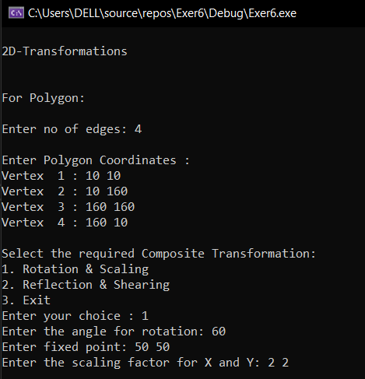

**Rotation & Scaling:**

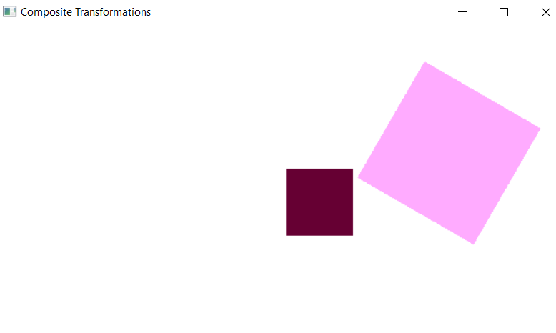

**2)Reflection & Shearing:**

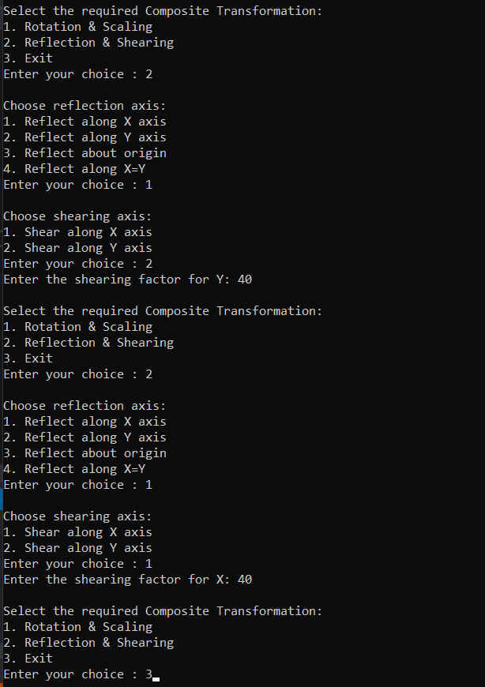

**Shearing Along Y:**

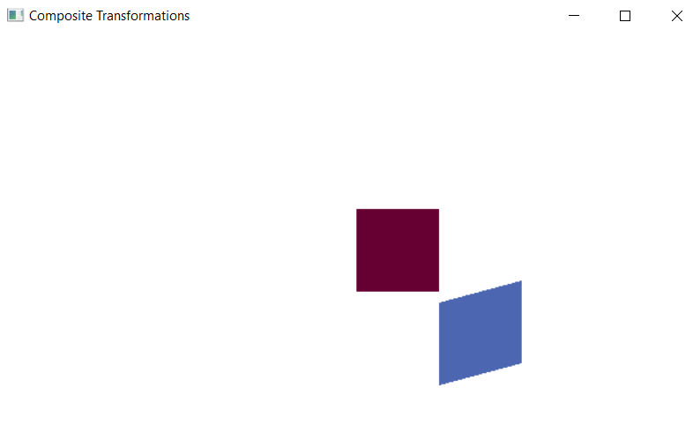

**Shearing Along X:**

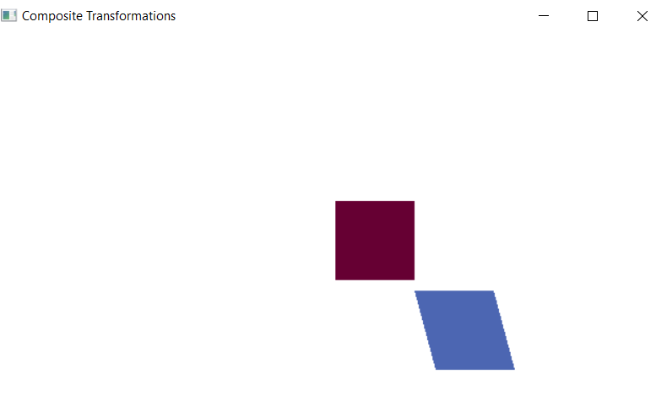

**Result:**

A C++ menu-driven program using OPENGL to perform 2D composite transformations for polygon was written and implemented successfully.